This procedure requires that the “Silicon Labs Virtual COM Port (VCP) Universal Driver” be installed on the machine where the ESP32 module will be plugged in using USB. Download driver from https://www.silabs.com/developer-tools/usb-to-uart-bridge-vcp-drivers?tab=downloads to install.


Click on + NEW DEVICE at bottom right of the screen
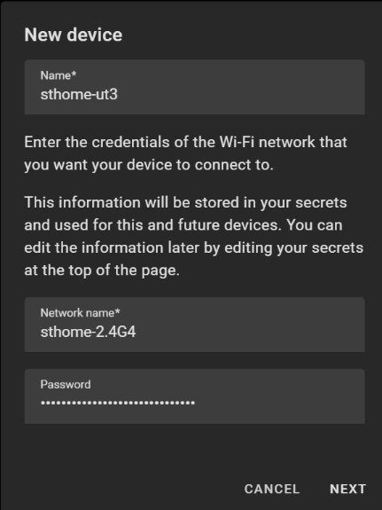

The “New device” dialog box will pop up.
Enter the following:
Name*: <new device name>
Network name*: <SSID of the Wifi for network device to connect to>
Password: <password of Wifi network>
Click NEXT

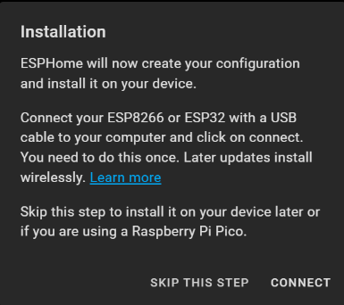
The “Installation” dialog box will pop up.
# Click “CONNECT”
Click on “SKIP THE STEP”

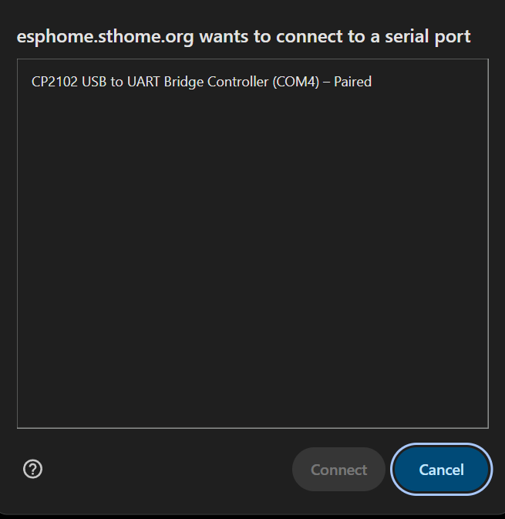
# The serial port connect dialog box will pop up.
# By now you should have installed the Virtual COM Port (VCP) drivers
# Select the appropriate COM port and click “Connect”

# The installation will take a few minutes.

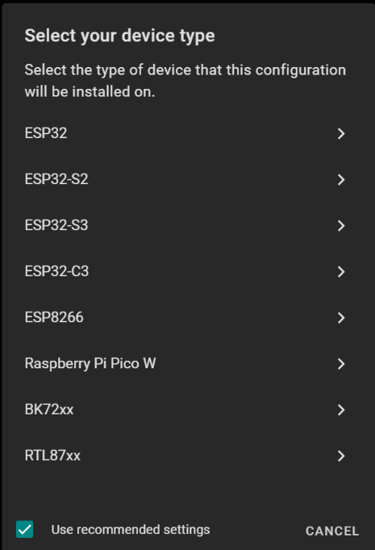
The “Select your device type” dialog box will pop up
Select “ESP32”

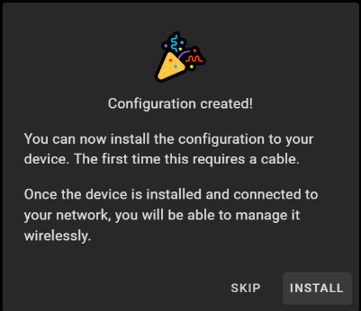
A “<device name>.yaml” file will be created in the config folder. In the case of this
Example it will be “sthome-ut3.yaml”
The “Configuration created” message box will pop up:
Click “INSTALL”

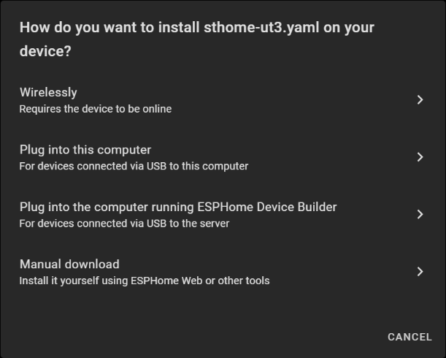
A “How do you want to install <device name>.yaml on your device” dialog box will pop up.
Select “Plug into this computer”
The installation will take a few minutes.

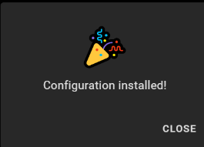
After successful install, click “CLOSE”

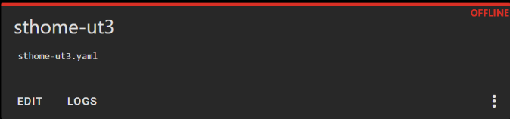
View the logs to see whether the ESP unit has connected to the Wifi network.
If required, edit secrets.yaml file in config folder to change the SSID
and/or password of Wifi network

